Project 3 Enhancements

Adding More Controls and Functionality
Make a new directory ”Project3More” and save as the form and project files StyleAndSize.FRM and StyleAndSize.VBP with new names StyleAndSize2.FRM and StyleAndSize2.VBP respectively.
Modify the form so that it looks like the diagram below:
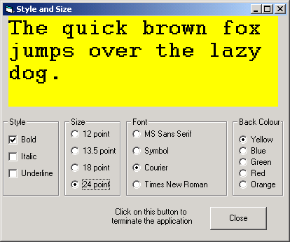
Code the Sub procedure for each of the new controls in order to introduce the required functionality. For example to change the font of the label used label.fontname="Symbol". There is no code supplied to test if you can develop code by yourself. If you are having difficulty with task write a line of pseudo code to describe the action required. For example from the previous part of the Project when setting the font size the line of code is as follows.
LabelText.FontSize = 18
The pseudo code of this statement is as follows. Let the fonts size of the label object called “Labeltext” be set to a value of eighteen.
For the background colour, use the palette in the property window to get the hexadecimal codes for the colours. Also use the property window to check if the required fonts are available, as some versions of Windows do not have a Roman Font (if so use some other font name).

Run the program and check that it functions correctly. Debug if necessary.
Produce a printout of your form, form text and code.

Extra Work
Can you think of any other modifications that might be useful?

